OWL HOUSE FOUNDATION (OHF) ANNUAL GENERAL MEETING
CHAIRMAN’S REPORT: 29 NOVEMBER 2025
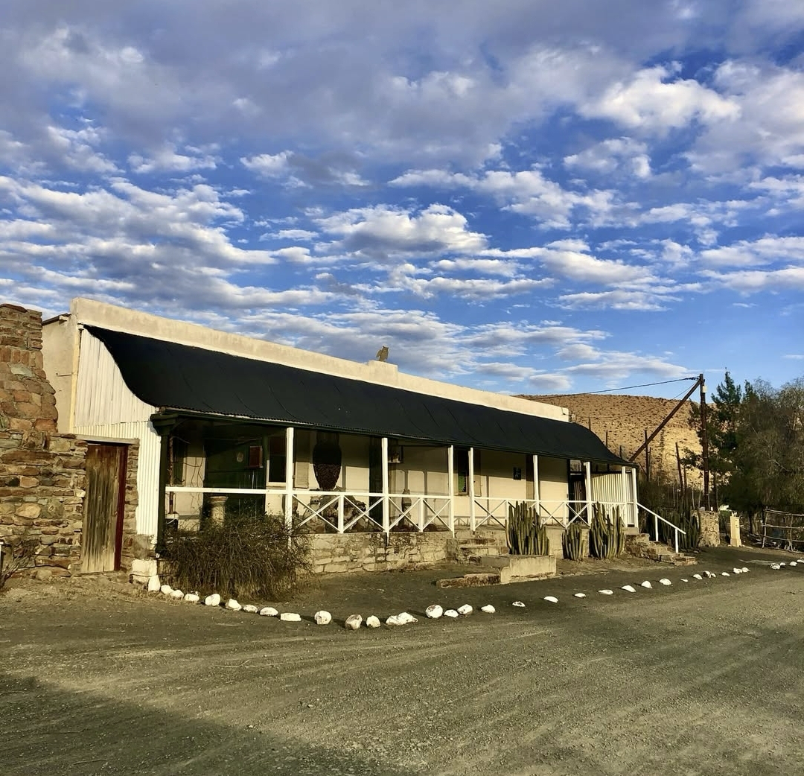
Introduction:
It is a privilege to address you at the end of another successful year of the Owl House Foundation (OHF) operations in Nieu Bethesda.
That the Owl House is in such a positive position is due to many years of combined effort by everyone who has supported the Owl House, led by current and previous OHF Board members. I and the rest of the current Board are deeply grateful to all those people, and very excited to continue the strong momentum into 2026. My Report below sets out the great deal of positive development which has happened this year. I’m very excited to share that with you now.

Review of 2025 Financial Year
1. Owl House Team - Internal, External advisers & Supporters:
I and the Board would like to highlight and thank the following people who have brought us forward to where we are today:
- The in-house OHF team - led by Manager Venique Barendse.
Thank you Venique, Bernie, Angela, Michelle and Michaela for your dedication. Without you we would not be able to open the Owl House doors and share this unique treasure with the outside world
- Charles Graham
The biggest thank you to Charles who passed on the baton to Joanne Pringle in July this year after serving the OHF for just over 11 years. Charles joined the team at a challenging time and has since then, first as an employee, and then as a contractor after COVID, ensured continuity in the administration of the OHF, including the financial accounting operations. Charles in his quiet, unassuming and competent way was a key member of the OHF for more than a decade
- Joanne Pingle
Thank you to Joanne for taking over the role as Financial and Administrative Manager at an important time in order to streamline the accounting function where many more demands are being made to comply with legislative and accounting best practice
- Other contractors and advisors to whom we owe thanks are:
  - Jurie Smith from The Labour Co in Graaff-Reinet
  - Rowan van Gend as Town Planner to the OHF and in particular his role in liaising with the Dr Beyers Naude Local Municipality (DBNLM)
  - Derek Light as our legal counsel and much measure advisor
  - Van Wyk Theron for their accounting services/ guidance and public company secretarial consultancy.
  - Joze Maleta for general IT support and cloud services
  - Mike O’Brien for his pro bono services taking care of the new and changing requirements of the OHF website
  - a big thank you to Fulvio de Stefanis and Albie van Schalkwyk (Oude Pastorie) for their ongoing generosity for many years in making their home available at no cost to those involved in pro bono work at the Owl House

2. Ongoing Owl House restoration – preservation, conservation and maintanance:
The principal goal of the OHF is the protection, preservation, conservation, maintenance and promotion of the Museum known as The Owl House. This is enshrined in the Memorandum of Incorporation (MOI) of the OHF.
The preservation, conservation and maintenance of the Owl House and Camel Yard continues to be the OHF’s top priority.
2.1. OHF Curator:
Anyone who has any involvement with the OHF will know the immensely important role Amanda Snyman, as the official OHF curator, plays on every level to maintain the vision of Helen Martin’s Owl House.
Simply put, Amanda is one of Miss Helen's angels.
It is a joy to see Amanda’s ongoing work to restore Miss Helen’s house and the Camel Yard sculptures which have been standing exposed in the often harsh Karoo environment for almost 50 years now.
2.2. Rupert Historic Homes Foundation grant (RHHF):
We wish to give the greatest thanks again to the RHHF for their grant of R500,000 for the restoration of Helen Martin’s house. The grant came at an important time in the house’s existence where many issues needed attention. For instance, a leaking roof and an external wall that needed to be rebuilt.
Many thanks to heritage consultant Chris Maree for his help to secure that grant. His passion for restoring heritage buildings was a gift to the OHF. Chris’ commitment, professionalism and dedication to the task made all the difference.
Included in the grant was a training component for the OHF team and the Crafters. That took place and was completed in March 2025.
The entire restoration project was successfully completed, and within budget, early in 2025. Chris submitted a comprehensive 91 page report to SAHRA, the likes of which I am sure the South African Heritage Resources Agency does not often see. It was exemplary! Please contact the OHF if any member would like to see the report.
2.3 UCT 3D scanning - a circa R500,000 project:
On a very exciting note, Global Digital Heritage Afrika, a research group at the University of Cape Town, completed the digital documentation of the Owl House in October by using up to the minute laser scanning technology. The Owl House and the key Camel Yard sculptures have now been captured for posterity, and a 3D online exploration is planned for viewing, and use for academic, restoration and promotional purposes in 2026.
Thank you Anne and Tessa Graaff for their introduction to the UCT team which made this project possible. Also to Anne for making her home in Nieu Bethesda (Murrayfield) available for the UCT team to stay for the week. Amanda Snyman has also had the opportunity on many occasions of staying with Denise Hope in her guest flat, on this occasion for the 3d scanning project. We are extremely fortunate that OHF board member, Stefano Nappo, led the project on behalf of the OHF.
The scanning aspect of the project is made possible by the significant contribution thus far by UCT to the value of R320,000, with the OHF of R80,000.
For those interested in the details, the project comprises:
- Laser scanning of the Camel Yard, artefacts in the Camel Yard, the Owl House interior and exterior
- Surveying of the site by means of drone photography and creation of a new plan and cross-reference to existing plans for the Camel Yard sculptures
- Production in due course of a 3D model of the Owl House, Camel Yard and selected artefacts, which will be accessible to the public worldwide.
The goal is for all activities in this project, including the delivery of the finished online digital experience, to be completed by the end of Summer 2026.
2.4 The David Graaff Foundation:
A big thank you for the ongoing financial contributions from the David Graaff Foundation and for the consistent support over the years. It is generous financial contributions such as theirs which sustains the work of the OHF.
In 2025 these funds were made available to Amanda Snyman for specific restoration activities at the Owl House.

3. Owl House Social Media:
We have a modest:
- Facebook page,
- Instagram account, and
- Website.
Despite his many commitments, a big thank you to board member Eugene Hön for running with this.
Funding and resourcing remains an important challenge in this regard.
The OHF is mindful of the importance of International outreach. In this regard on a recent trip to Europe, I had the opportunity of travelling to, and making contact with, two outsider art museums in Switzerland :
- Collection De L’Art Brut Lausanne: one of three museums in Lausanne supported by the City - contact is Sophie Guyout - Head of Communications. Next year the museum celebrates 50 years since the donation of the founding collection by French painter Jean Dubuffet
- Open Art Museum St Gallen - contact is Dr. phil. Monika Jagfeld - Curator
Promotional outreach opportunities will emanate from this connection, and together with the digital online experience, in 2026 we will act to further raise the profile of the Owl House internationally.

4. ‘For the Love of Light’ - the definitive pictoral recordof the Owl House:
Following previous discussions on the pictorial record of the Owl House in the book ‘For the Love of Light’ commissioned by the OHF, further constructive comment was received from Wilhelm van Rensburg from Strauss & co which have been incorporated into the design and content of the book.
Much personal commitment and consideration by Elzilda Becker, Merwelene Van Der Merwe and Team has gone into the book in telling Helen’s story in this primarily visual way.
The OHF is now the owner of all the intellectual property (IP) in the photos and other works created for the book, a significant asset the OHF will use to further its aims. That is especially useful in order to raise funds. Apart from sales of the book itself, carefully chosen merchandising opportunities using that IP will be explored further in 2026 for the Owl House shop and otherwise e.g. online.
Obtaining sponsorship to print the completed book remains a challenge. We have not found the goose/geese with the golden egg/s yet, but continue to follow up leads as we hunt them down. Please pass on any potential leads we could follow that you may be aware of.

5. The Crafters precinct:
I would like to repeat here an extract of my comments from my 2024 AGM report:
“In my Chairman’s report of 2023 I noted the background to the Crafter’s Precinct to where we are today. I would encourage you to read it as background to any discussion going forward.
The responsibility for providing traders' stalls within a Crafters Precinct is vested in and acknowledged by the DBNLM.
The OHF in 2019 agreed, in conjunction with the DBNLM, to facilitate the process of drafting and submitting an application for the rezoning of the road reserved outside the OH premises, as well as facilitating the construction of such a precinct.
The rezoning for the road reserve was granted by the DBNLM in November 2022, but almost immediately was followed by an appeal against this decision on 28 November 2022.
Despite the Spatial Planning and Land-Use management (SPLUMA) by-laws requiring that an appeal hearing take place within required dates, and the DBNLM notice that such a hearing would take place on 23 January 2023, this did not happen.
After numerous follow up requests resulting in no action, the OHF has submitted two letters of demand to the DBNLM that the appeal hearing take place by a prescribed date.
In addition the OHF Professional Town and Regional Planner has submitted a complaint to the MEC of the Department of Co-operative Governance and Traditional Affairs (COGTA) to intervene and get the DBNLM to convene the outstanding appeal hearing.
The OHF does not have the capacity to take on the DBNLM responsibility of establishing and managing a Crafters Precinct on its own premises, and does not agree that the Crafters should be housed, temporarily or otherwise, on OHF property.”
Action in 2025:
Despite ongoing follow up and pressure by the OHF town Planner, Rowan van Gend, no progress was made on the appeal hearing. As a result Deputy Minister Samantha Graham-Maré facilitated a meeting with Mayor Willem Safers of the Dr Beyers Naude Local Municipality, at the Mayor’s request, on 18 July 2025. Disappointingly the Mayor did not attend the meeting with myself, Fulvio de Stefanis (previous Chairman of the OHF) - both of us having driven up from Johannesburg for the meeting - Deputy Minister Samantha Graham-Maré, board member Bruce Rubidge and OHF manager Venique Barendse.
I followed up the non-attendance with a strongly worded letter to the Mayor dated 7 August 2025. The letter noted the DBNLM’s previous acknowledgement at a Board meeting dd 22 October 2021, as signed by Municipal Manager Dr E. M. Rankawa, of the DBNLM responsibility to provide appropriate stalls for the Crafters. At the 3 July meeting DBLNM committed that the Mayor would respond within 14 days to the issues raised. This has still not happened.
In September 2025, Board member Bruce Rubidge hosted the Deputy Director General of Tourism on a paleontological visit to Nieu Bethesda and a tour of the Owl House. Understandably the Deputy Minister was shocked by the lack of engagement and the lack of DBLNM’s fulfillment of their duties. The Deputy Minister then took the issue up with the Minister who wrote to the Mayor on 2 October requesting action and feedback.
Despite Ministerial intervention, the OHF has not heard of any action yet taken by DBLNM .
However the OHF remains committed to facilitating a humane and dignified solution to the long outstanding Crafters Precinct, and will not give up its fight to bring that about.

6. Key Finance Indicators for the period ending 30 June 2025:
Despite the challenges facing a small town in the Karoo, the OHF results continued to improve compared to the previous financial year. In particular the OHF has obtained a short term increase in funds as prices have been geared up for an anticipated VAT liability:
- visitor numbers dropped to 9,139 compared to circa 10,600 for the previous period. This is in line with reports of reduced tourism numbers in the Eastern Cape
- Revenue decrease by R56,254 ( 6%)
- Shop revenue increase by R12,672 (6%)
- Total expenses: decreased significantly by R280,443 mainly due to reduced consulting/ professional fees & less repairs & maintenance due to RHHF grant
As a result the Owl House made a net profit of R166,394 compared to a loss of (R39,322) the previous year.
The overall statement of financials reflects a healthy position, where assets are greater than liabilities, resulting in an equity and accumulated surplus of R1.8 million Rand, reflecting an improvement of R166,000.
(Refer to Annual Financial Statements for more detail - circulated with the AGM notification, or on the OHF website.)
As stated previously, the importance of new revenue streams is uppermost in our minds:
- finding new ways of attracting visitors to the OH
- further improved curation of the shop offerings leveraging the OHF’s IP
- investigating online selling opportunities
- rolling out the definitive pictorial Owl House book
- merchandising and licensing opportunities related to book photos
The Board welcomes all constructive ideas to raise new revenue and eagerly awaits ideas from our Members.

7. Security upgrade:
During 2025 the Board decided it was prudent to look at security upgrades for the OHF. As a result cameras have been installed in the administrative buildings of the OHF, as well as the Camel Yard, but not yet the Owl House itself. A suitable solution (probably wireless) for that is still being researched.
SAHRA is supportive of this initiative.

8. Registration for S18A tax relief for the OHF NPC:
After a number of false starts, the OHF approached an experienced specialist company in 2025 to make an application to SA Revenue Services (SARS) for S18A status.Obtaining that would allow donors to the OHF to obtain SARS tax deductions.
Unfortunately the OHF’s application was not granted. We had the opportunity to appeal and did so. It has been submitted that:
- The Foundation's activities fall within the scope of Part 1 & Part II of the Ninth Schedule to the Income Tax Act, Section 30, which outlines qualifying public benefit activities under the category of Welfare and Humanitarian.
We await the result of the appeal process.

9. Looking Forward: 2026
Next year we will commemorate the 50-year anniversary of the passing of Helen Martins and the legacy she left. Miss Helen, as she was fondly called, passed away on 8 August 1976.
This is an opportunity not to be missed by the Owl House and the town of Nieu Bethesda.
These are some of our early thoughts on initiatives as we head to 2026:
- focus on finding funding for the continued restoration of the Owl House itself and for work on the Camel Yard. The recent 3D mapping exercise by UCT will be very useful to help achieve this
- establishment of a Memorial Garden on OHF property, Board member Daniel van der Merwe, a landscape architect, has created a first concept for this project which the Board will consider. The OHF will share details in due course in 2026
- placing of a sculpture of Helen Martins gifted by multitalented South African artist, Angus Taylor in the Memorial Garden
- international outreach to obtain further recognition of the OH as a world class outsider art monument (see 3.)
- ramping up the product selection in the OH shop and Crafter creations to support the events - in progress
- a plaque unveiling by the South African Heritage Resources Agency (SAHRA)
- high profile political attendance at a commemorative function. The Minister of Arts & Culture has indicated willingness to speak at the commemorative event
- engaging with the local community on collaborative opportunities (e.g. Nieu Bethesda tourism, businesses & NB Residents’ & Ratepayers’ Association)
- focused lectures/ discussions/ tours on all matters pertaining to the OH and Miss Helen’s place amongst other outsider artists Internationally
- crafting a 50 year commemoration logo - Eugene Hön
We appeal to the local community to contribute towards a successful and far reaching 50th year commemoration. This of course benefits every single individual in Nieu Bethesda through amongst other,
- bringing in recognition
- attraction of tourists
- maintaining of property values and individual investments made to living in this jewel of the Karoo
Please let us know of any further thoughts you may have about the commemoration.

10. Challenges and Opportunities:
I have discussed the funding challenges under Finance in point 6.
The need for appropriately trained and passionate tour guides remains. We continue to investigate opportunities to make this viable. If anyone would like to explore becoming a tour guide with us, please get in touch.
We would like to put the word out again with a request for volunteers from the community to assist in the work of the OHF. Should you be interested, please make it known to us, via email/ social media or a visit to the OHF offices.

11. The Owl House Board:
The best for last again, the GREATEST thanks to my fellow Board Directors for their unwavering commitment to the vision of the Owl House Foundation and preservation of the National Heritage Site that is the Owl House:
- Nils Flaatten (Vice Chair)
- Samantha Graham-Maré
- Bruce Rubidge (Treasurer)
- Eugene Hön
- Daniel van der Merwe
- Stefano Nappo

12. Conclusion:
Helen Martins is South Africa’s most important outsider artist and the OH must be preserved for future generations.
Finally, thank You the members of the OHF for your interest, your feedback and support and – of course – your belief that Helen’s work must be shared.

André Pierre Marais
Owl House Foundation - Chairman
29 November 2025

Sign about Outside Artists at the Collection De L’Art Brut Lausanne:
